04 - Iteration Control Structures

Ex. No. : 4.1 Date: 10.04.2024
Register No.: 231401091 Name: SAKTHI ELUMALAI MANICKAVELU

Factors of a number
Determine the factors of a number (i.e., all positive integer values that evenly divide into a number).
For example:
Input | Result
20 | 1 2 4 5 10 20
k=int(input())
l=[]
for i in range(1,k+1):
if(k%i==0):
l.append(i)
for j in l:
print(j,end=' ')

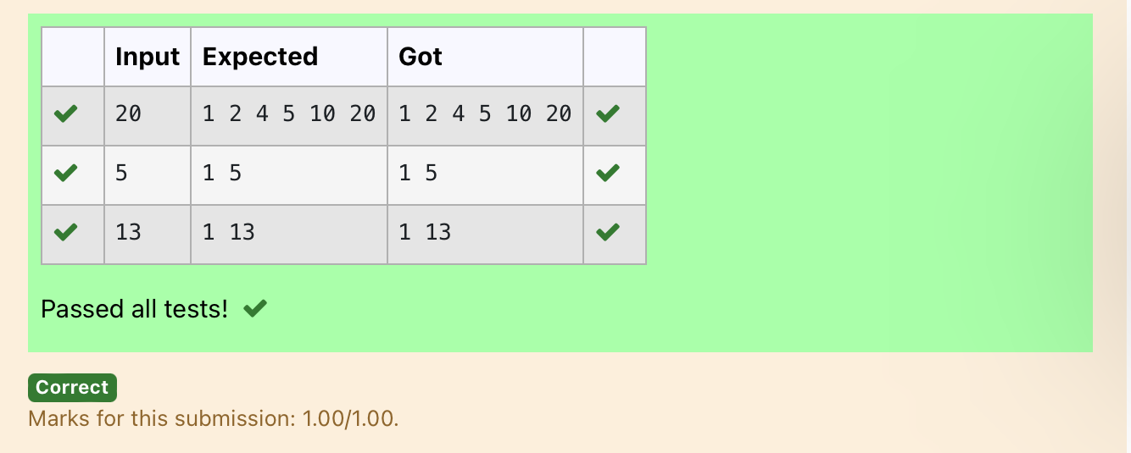

Ex. No. : 4.2 Date: 10.04.2024
Register No.: 231401091 Name: SAKTHI ELUMALAI MANICKAVELU

Non Repeated Digit Count
Write a program to find the count of non-repeated digits in a given number N. The number will be passed to the program as an input of type int.
Assumption: The input number will be a positive integer number >= 1 and <= 25000.
Some examples are as below.
If the given number is 292, the program should return 1 because there is only 1 non-repeated digit '9' in this number
If the given number is 1015, the program should return 2 because there are 2 non-repeated digits in this number, '0', and '5'.
If the given number is 108, the program should return 3 because there are 3 non-repeated digits in this number, '1', '0', and '8'.
If the given number is 22, the function should return 0 because there are NO non-repeated digits in this number.

For example:
Input | Result
292 | 1
1015 | 2
108 | 3
22 | 0
n=int(input())
l=[]
k=[]
while n>0:
a=n%10
n=n//10
l.append(a)
for i in range(len(l)):
if l.count(l[i])==1:
k.append(l[i])
print(len(k))

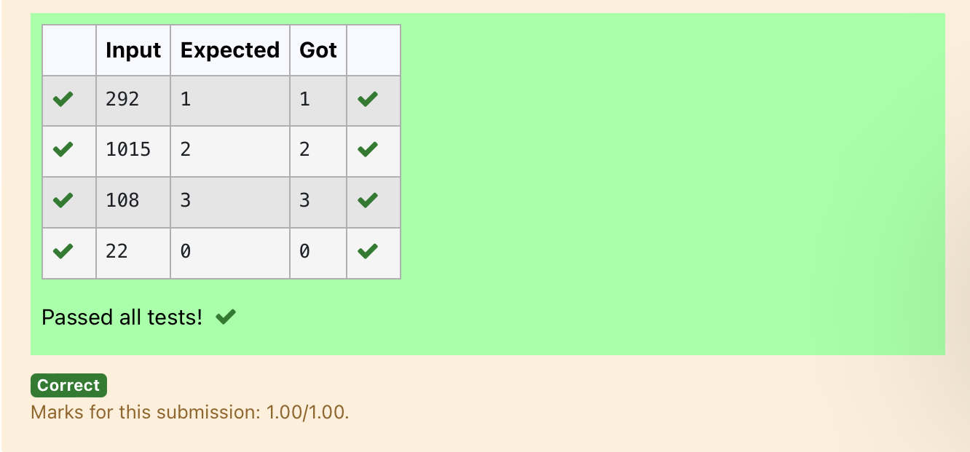

Ex. No. : 4.3 Date: 10.04.2024
Register No.: 231401091 Name: SAKTHI ELUMALAI MANICKAVELU

Prime Checking
Write a program that finds whether the given number N is Prime or not. If the number is prime, the program should return 2 else it must return 1.
Assumption: 2 <= N <=5000, where N is the given number.
Example1: if the given number N is 7, the method must return 2
Example2: if the given number N is 10, the method must return 1

For example:
Input | Result
7 | 2
10 | 1

a=int(input())
for i in range(2,a):
if(a%2==0):
flag=0
elif(a%i!=0):
flag=1
else:
flag=0
if(flag==1):
print("2")
elif(flag==0):
print("1")

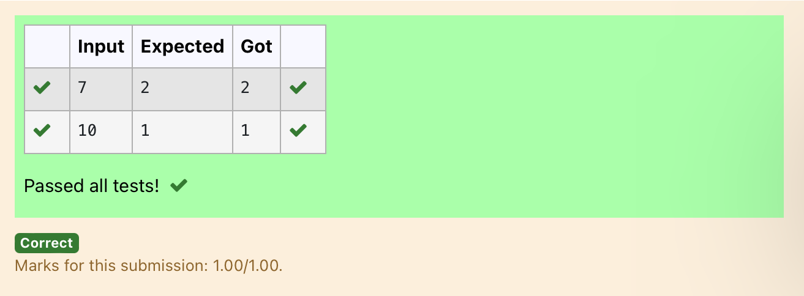

Ex. No. : 4.4 Date: 10.04.2024
Register No.: 231401091 Name: SAKTHI ELUMALAI MANICKAVELU

Next Perfect Square
Given a number N, find the next perfect square greater than N.
Input Format:
Integer input from stdin.
Output Format:
Perfect square greater than N.
Example Input:
10
Output:
16

a=int(input())
c=[]
for i in range(0,a):
b=i**2
if(b>a):
c.append(b)
print(c[0])

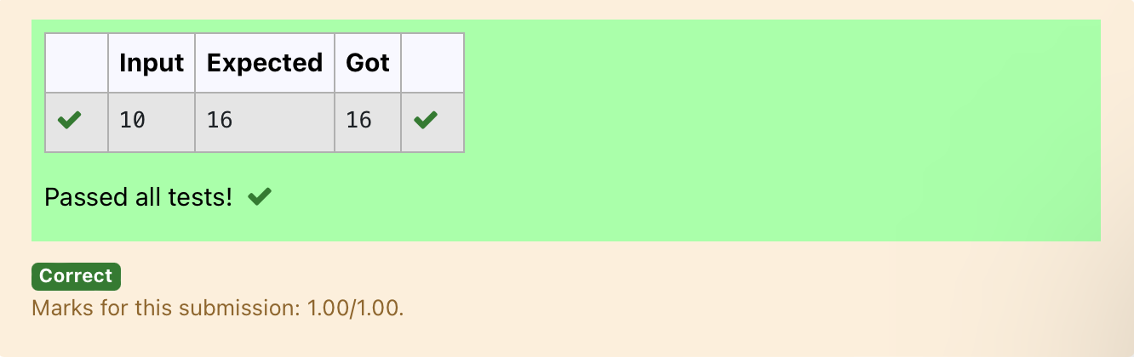

Ex. No. : 4.5 Date: 10.04.2024
Register No.: 231401091 Name: SAKTHI ELUMALAI MANICKAVELU

Nth Fibonacci
Write a program to return the nth number in the fibonacci series. The value of N will be passed to the program as input.

NOTE: Fibonacci series looks like –
0, 1, 1, 2, 3, 5, 8, 13, 21, 34, 55, . . . and so on.
i.e. Fibonacci series starts with 0 and 1, and continues generating the next number as the sum of the previous two numbers.
• first Fibonacci number is 0,
• second Fibonacci number is 1,
• third Fibonacci number is 1,
• fourth Fibonacci number is 2,
• fifth Fibonacci number is 3,
• sixth Fibonacci number is 5,
• seventh Fibonacci number is 8, and so on.

For example:
Input:
7
Output
8

a=[0,1]
for i in range(0,100):
a.append(a[-1]+a[-2])
q=int(input())
print(a[q-1])

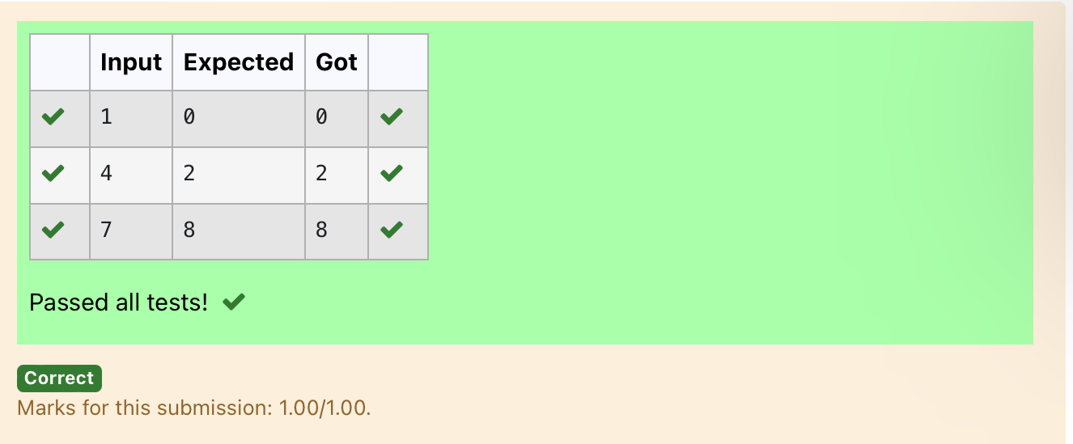

Ex. No. : 4.6 Date: 10.04.2024
Register No.: 231401091 Name :SAKTHI ELUMALAI MANICKAVELU

Disarium Number
A Number is said to be Disarium number when the sum of its digit raised to the power of their respective positions becomes equal to the number itself. Write a program to print number is Disarium or not.

Input Format:
Single Integer Input from stdin.
Output Format:
Yes or No.
Example Input:
175
Output:
Yes
Explanation
1^1 + 7^2 +5^3 = 175
Example Input:
123
Output:
No
For example:
Input | Result
175 | Yes
123 | No

import math
n=int(input())
a=len(str(n))
sum=0
x=n
while(x!=0):
r=x%10
sum=int(sum+math.pow(r,a))
a-=1
x=x//10
if(sum==n):
print("Yes")
else:
print("No")

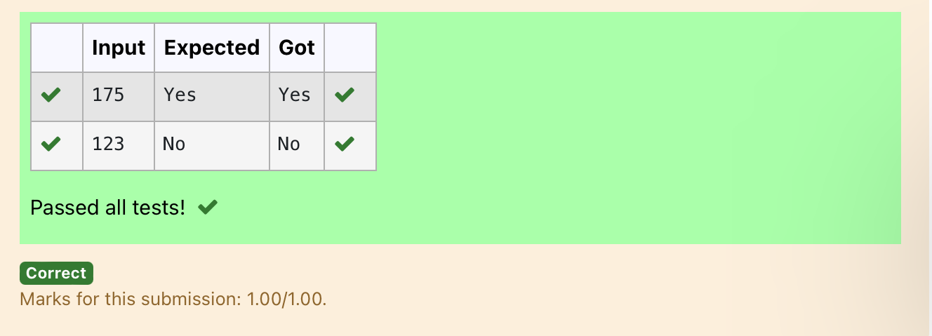

Ex. No. : 4.7 Date: 10.04.2024
Register No.: 231401091 Name: SAKTHI ELUMALAI MANICKAVELU

Sum of Series
Write a program to find the sum of the series 1 +11 + 111 + 1111 + . . . + n terms (n will be given as input from the user and sum will be the output)
Sample Test Cases
Test Case 1
Input
4
Output
1234
Explanation:
as input is 4, have to take 4 terms.
1 + 11 + 111 + 1111

Test Case 2
Input
6
Output
123456
For example:
Input | Result
3 | 123
n=int(input())
b=1
sum=0
for i in range(1,n+1):
sum+=b
b=(b*10)+1
print(sum)

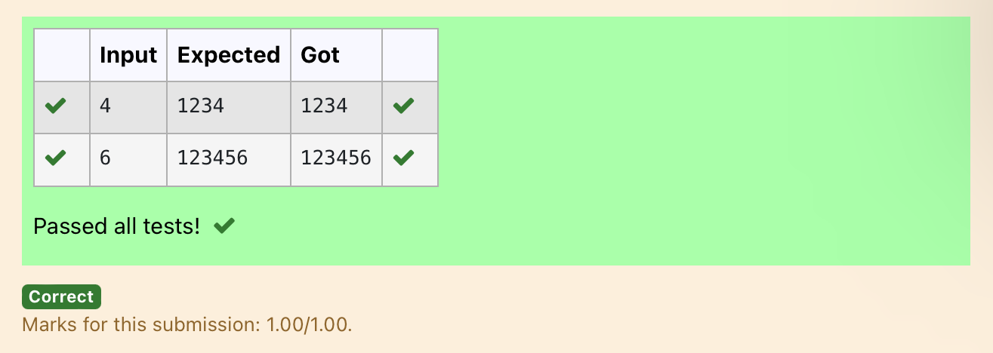

Ex. No. : 4.8 Date: 10.04.2024
Register No.: 231401091 Name: SAKTHI ELUMALAI MANICKAVELU
Unique Digit Count
Write a program to find the count of unique digits in a given number N. The number will be passed to the program as an input of type int.
Assumption: The input number will be a positive integer number >= 1 and <= 25000.
For e.g.
If the given number is 292, the program should return 2 because there are only 2 unique digits '2' and '9' in this number
If the given number is 1015, the program should return 3 because there are 3 unique digits in this number, '1', '0', and '5'.
For example:
Input | Result
292 | 2
1015 | 3

a=int(input())
b=[]
while a>0:
c=a%10
a=a//10
b.append(c)
b=list(set(b))
print(len(b))

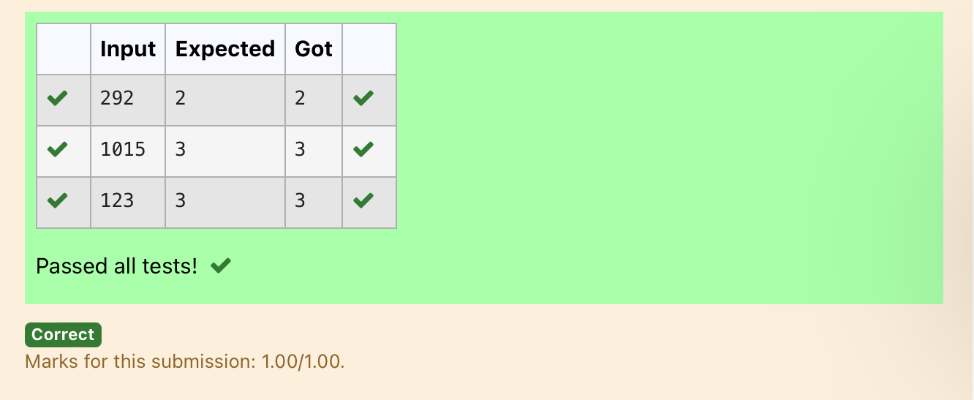

Ex. No. : 4.9 Date: 10.04.2024
Register No.: 231401091 Name: SAKTHI ELUMALAI MANICKAVELU

Product of single digit
Given a positive integer N, check whether it can be represented as a product of single digit numbers.
Input Format:
Single Integer input.
Output Format:
Output displays Yes if condition satisfies else prints No.
Example Input:
14
Output:
Yes
Example Input:
13
Output:
No

a=int(input())
flag=0
for i in range(10):
for j in range(10):
if(i*j==a):
flag=1
break
if(flag==1):
print("Yes")
else:
print("No")

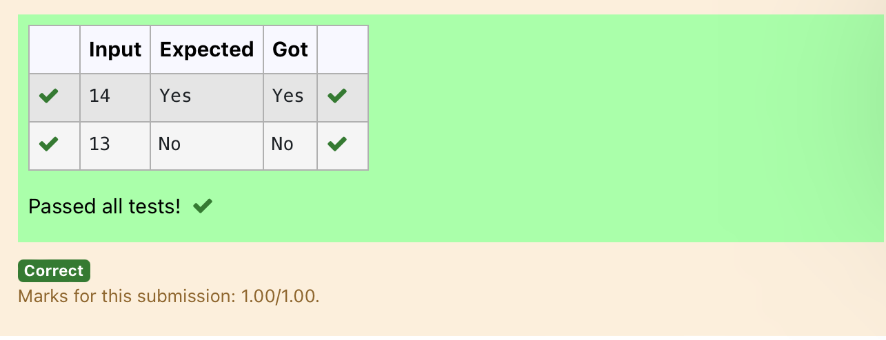

Ex. No. : 4.10 Date: 10.04.2024
Register No.: 231401091 Name: SAKTHI ELUMALAI MANICKAVELU

Perfect Square After adding One
Given an integer N, check whether N the given number can be made a perfect square after adding 1 to it.
Input Format:
Single integer input.
Output Format:
Yes or No.
Example Input:
24
Output:
Yes
Example Input:
26
Output:
No
For example:
Input | Result
24 | Yes

import math
n=int(input())
a=n+1
sr=int(math.sqrt(a))
if(sr*sr==a):
print("Yes")
else:
print("No")



